2018 Joint Conference on Digital Libraries

Information Architecture

Website Design Report

**TEAM ONE – Loring Faiivae, Edmund (Steven) Lowe, and Rabecca Pate**

**August 8, 2017**

Table of Contents

1.1 Executive Summary 4

Project Plan 4

2.1 Context and Background 5

2.1.1 Organization 5

2.1.2 Stakeholders 5

2.1.3 Technology Assessment 6

3.1 Content Research 6

3.1.1 Benchmarking and Lessons Learned 6

3.1.2 Metadata and Content Analysis 11

Content Analysis 11

Metadata 13

4.1 Users 14

4.1.1 Card Sorting 14

5.1 Blueprints 14

5.1.1 Blueprint – Home Page High-level diagram 15

5.2 Wireframes 16

5.2.1 Low Fidelity Wireframe (See Figure 1) 16

5.2.2 Medium Fidelity Wireframe (See Figure 2) 16

5.2.3 High Fidelity Wireframe (See Figure 3) 16

Figure 1 – Low Fidelity Wireframe – Home Page 17

Figure 2 – Medium Fidelity Wireframe – Home Page 18

Figure 3 High Fidelity Wireframe – Home Page 19

5.3 Content Mapping and Inventory 20

5.3.1 JCDL 2018 Content Mapping and Inventory 20

5.4 Controlled Vocabulary 23

5.5 Summary of Team Interaction 27

6.1 Prototype for New Site 27

6.2 Design Implementation 28

6.3 Personal Reflections 29

6.3.1 Statement from Loring Faiivae 29

6.3.2 Statement from Edmund (Steven) Lowe 29

6.3.3 Statement from Rabecca Pate 30

References 31

Appendix A – Card Sort 32

A.1 - Card Sort Summary 32

A.2 - Card Sort Summary Standardized 32

A.3 – Card Sort Correlation 33

# Executive Summary

The Team One term project for class INFO 4745/5745 involves the design and creation of the 2018 Joint Conference on Digital Libraries (JCDL) website. The reason for the new 2018 JCDL website is to allow a portal for individuals interested in attending the 2018 conference a way to register for attendance to the conference. The website will also be an avenue for members or all who are interested in attending the event, to upload papers, view itinerary, get directions, visa information, and other basic information that is pertinent to the conference.

The members of Team One include Loring Faiivae, Edmund (Steven) Lowe, and Rabecca Pate. This report covers the information architecture planning and development design through the entire process of the creation of the JCDL 2018 website.

## Project Plan

Communication Plan:

Rabecca Pate has been nominated and excepted the role as team coordinator. Communication will be accomplished via Blackboard Learning, email, phone, texting, and messenger. If it is determined that a live meeting is needed either google chat or a 3-way conference call will take place. While contact has been almost every day, each team member will be required to check in at least three times a week on every Monday, Wednesday, and either Friday or Saturday.

Task Responsibilities for Deliverable 1:

|  |  |  |
| --- | --- | --- |
|  | | |
| 1.1, 1.2 | Rabecca Pate | Context and Background |
| 1.3.1 | Rabecca Pate | Benchmarking and lessons learned |
| 1.3.2 | Loring Faiivae, Edmund Lowe, & Rabecca Pate | Metadata and content Analysis |
| 1.4.4 | Edmund Lowe | Card Sorting |

# Context and Background

## Organization

The Joint Conference on Digital Libraries (JCDL) is a major international forum that allows for collaboration between researchers and practitioners so that they can exchange ideas as well as discuss issues related to digital libraries such as their design, development, sustaining, and evaluation.

According to their main website JCDL.org, “The intended community for this conference includes those interested in such aspects of digital libraries as infrastructure; institutions; metadata; content; services; digital preservation; system design; implementation; interface design; human-computer interaction; evaluation of performance; evaluation of usability; collection development; intellectual property; privacy; electronic publishing; document genres; multimedia; social, institutional, and policy issues; user communities; and associated theoretical topics” (About JCDL, n.d.).

JCDL wants to continue in their growth of attendees so that they can continue to inform researchers, practitioners, and students of the latest digital libraries research and development; discuss the different challenges and issues that the audience finds of great interests; exchange and share new additional resources; as well as identify future research and development directions for digital libraries. The JCDL wants to create a website for their 2018 conference in Ft. Worth Texas that makes registration for attendance, paper submission, as well as any pertinent information that the attendee may need about attending the conference accessible in one place with the utmost ease of usability.

## Stakeholders

The stakeholders are the JCDL 2018 organizing committee which takes care of the program organization such as; planning, application, organization, local arrangement, session-monitoring, workshops, panels, doctoral consortia and publication. Other stakeholders are all individuals within the United States and internationally who will be attending the JCDL 2018 conference. This can include both attendees who are there to listen and learn as well as key speakers. Stakeholders also includes sponsors and individuals who are just inquiring about the JCDL 2018 conference and are not attending the conference or who have not decided whether to attend.

## Technology Assessment

For this website Drupal will be used under the Windows operating system. The website will be created on Drupal through the class server Coolt-courses.lis.unt.edu.

# Content Research

## 3.1.1 Benchmarking and Lessons Learned

Content analysis was conducted by viewing the four websites JCDL considers competition which are: ASIS&T annual, ICKM, SIGIR, and TPDL. These four websites’ information architecture were examined for the purpose of learning by analyzing the different aspects of design, content, navigation schemes, and ease of usability.

#### 19th International Conference on Knowledge Management (ICKM 2017)

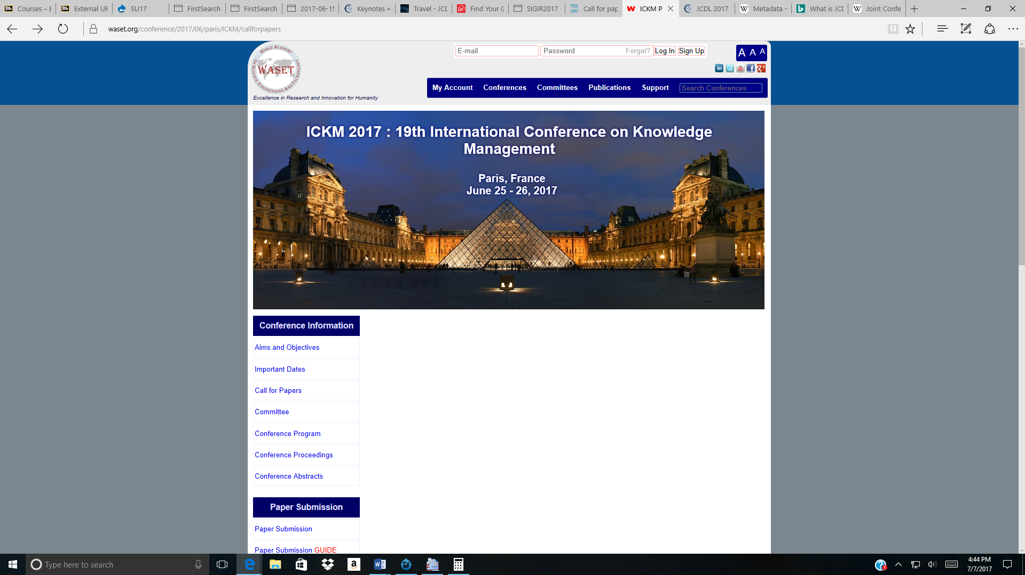

When examining the 19th International Conference on Knowledge Management (ICKM 2017) website at <https://www.waset.org/conference/2017/06/paris/ICKM/callforpapers> there was a lot of information and there were navigation links all over the place. While there were lots of links that provided clear understanding of what the user would be taken to, there were many links that would take the user to places with no clear understanding of how to return back to where the user started without hitting the back button. It also seemed that if a user clicked the Conference global navigation link, the user would be taken to a screen where the they could select which conference they were interested in. However, there were so many options to sort through that it became overwhelming. Also, it seemed that the global navigation links at the top of the website were for the waset.org site and not for the individual conference site. The individual conference global navigation links were at the left of the screen. This could become very confusing, especially to a new user inquiring about the conference.

Observations:

* Neatly organize content
* Use Headings and tabs when needed
* Use tables to separate calendar information or lists
* Use top of page links for pages with lots of content

#### 21st International Conference on Theory and Practice of Digital Libraries (TPDL 2017)

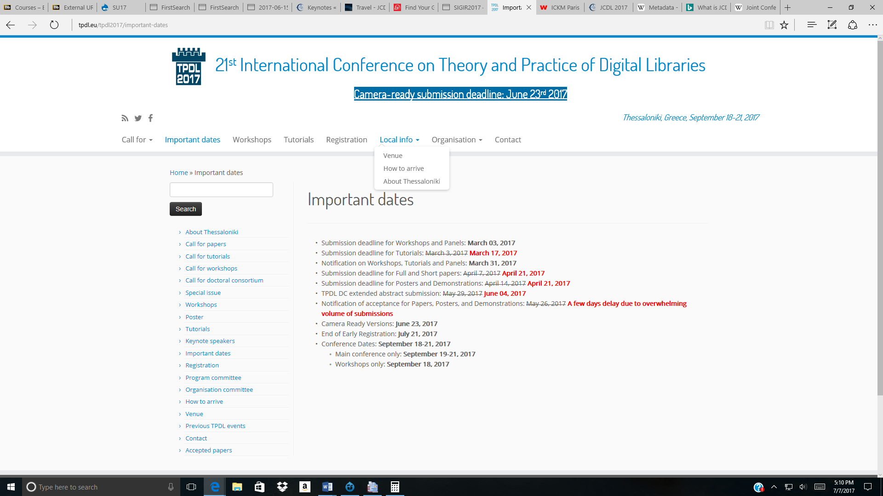

When examining the 21st International Conference on Theory and Practice of Digital Libraries (TPDL 2017) website there seemed to be redundant link on the same page. While there was a global navigation at the top of the screen with some having drop down menus for further options, there was the exact same links all listed to the left of the screen.

It seems that if every single link that is in the top global navigation is available to click at the left of the screen then why would top global navigation links be needed? Although, the top navigation links did have drop down menus for more links with more than one navigation option under it. This way a user can hover over the link and see if it contains a label they are looking for without having to click the link and wait for another screen to appear. This saves the user time. Another image from the TPDL 2017 website follows with all observations for both screenshots listed under it:

#### 21st International Conference on Theory and Practice of Digital Libraries (TPDL 2017)

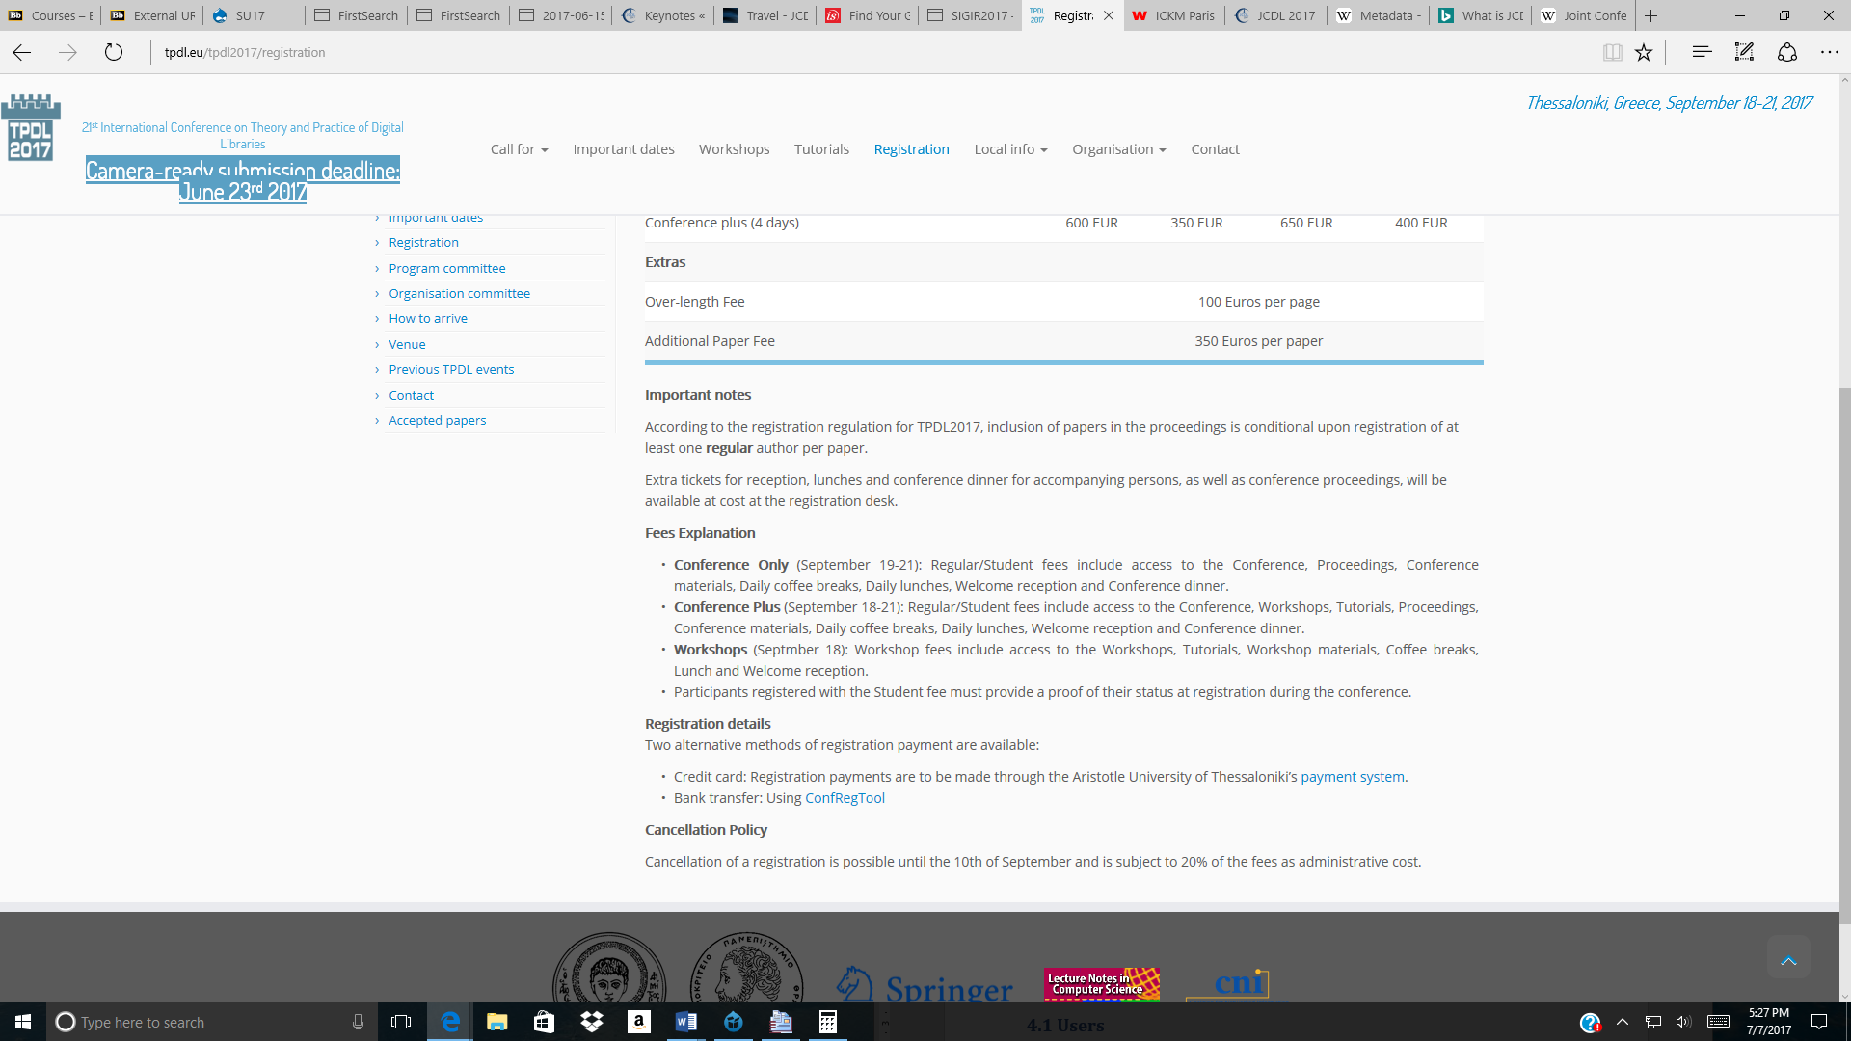

It was also very confusing when the Registration tab was clicked, most users would expect it to automatically take them to a screen where the user can register. However, when a user clicks the Register link, the first screen the user is taken to talks about Registration Fees and Important Notes; it is not until the bottom within the words that there are two different text links that will take the user to one of two different ways of paying and registering. Team One almost overlooked these registration links because the text links to register seemed like they were not related to registration. Only by trial and error did Team One realize that the link takes the user to a different website to register and provide payment for registration.

Observations:

* Use links that clearly stand out as a link; do not use textual link in the middle of a sentence that is supposed to take a user to something important such as Registration.
* Put important links such as Registration at the top of page if the original link says Registration.
* Only one set of navigation links should be used on conference page with only one link that takes user back to main Organization website.
* Choose a consistent style of navigation links.
* Do not have global navigation link at top with links under links and then have every single link also located to the left at all times. Choose one or the other.
* Separate local navigation and global navigation links.

#### 40th International ACM SIGIR Conference website (SIGIR 2017)

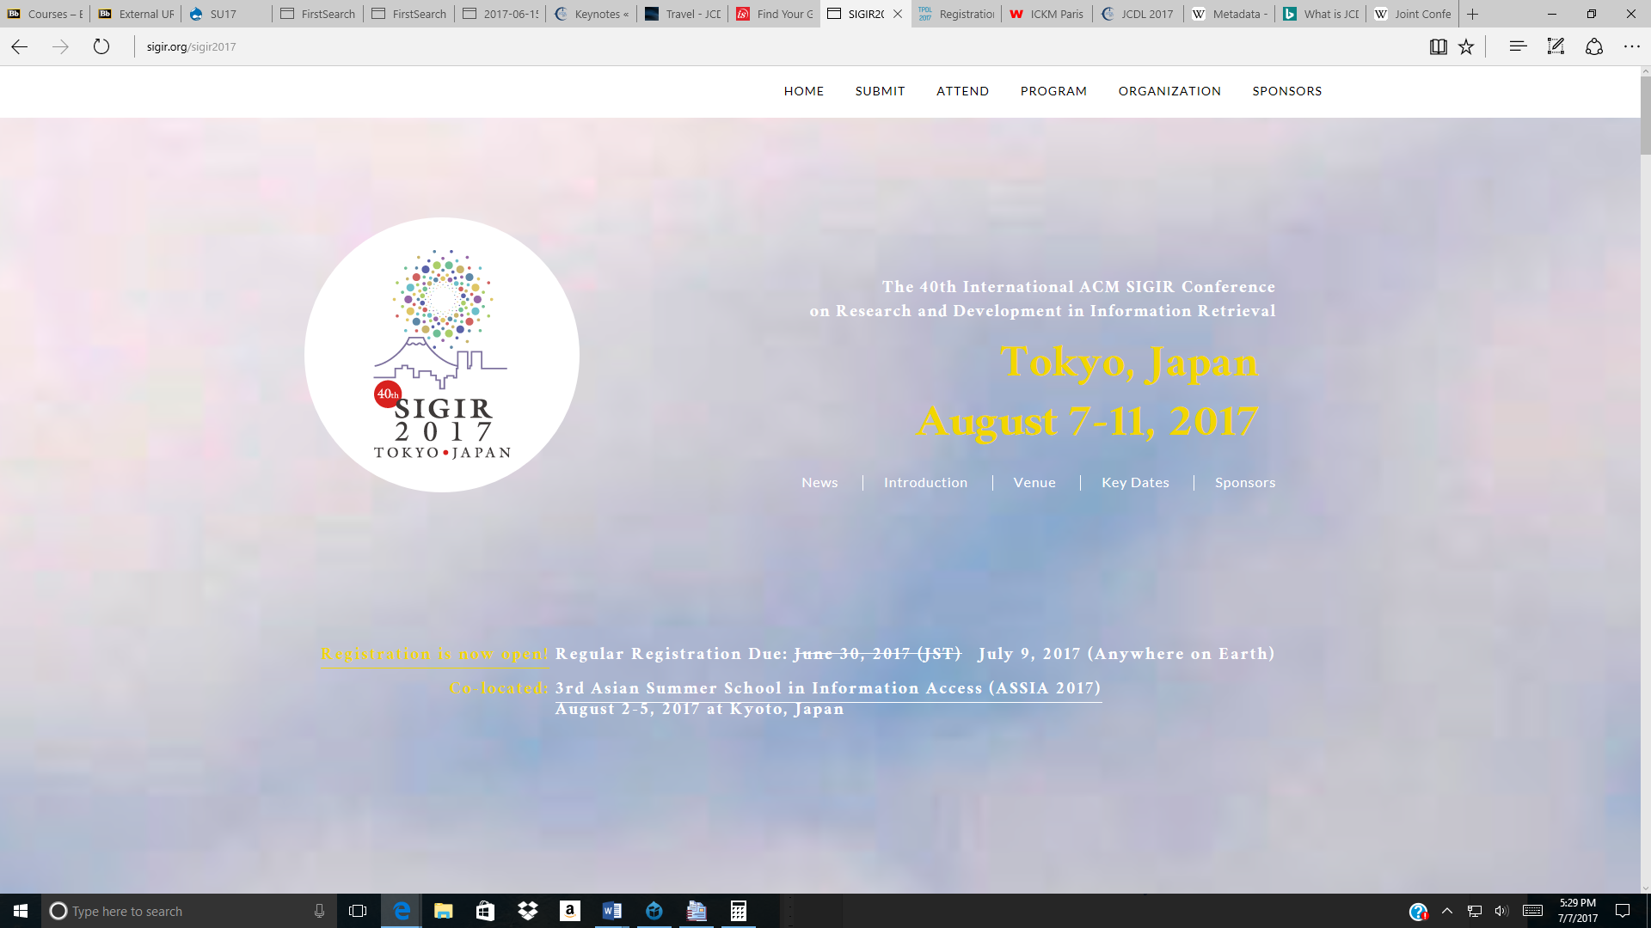

When examining the 40th International ACM SIGIR Conference website (SIGIR 2017), it seemed everything was neatly organized. However, after clicking the links in the middle of the page under the date August 7-11, 2017, it seemed the links only took the user to information within the same page just located further down. Although, it was nice that at all times there was an arrow link that the user could click that would immediately take them back to the top. It wasn’t until the third time that it was finally noticed that there was global navigation links located at the very top of the page in the white area. These links seemed hidden at first because they seemed to blend in.

However, this website utilized really nice drop-down menus for further navigation. It was also very well organized by different events and date and times. Nothing seemed hard to decipher, or hard to find. When the user clicks the Registration tab, they are taken to the Registration page with the Registration button listed as the very first thing, followed with facts regarding registration such as fees, what registration includes, payment information, and Visa information.

Observations:

* Need to ensure global navigation labels are seen at all times, make sure they don’t blend in with borders or pictures.
* If large amount of text on a page have a link that can take user back to top of page immediately.
* Use drop-down menus for global navigation links when mouse icon is hoovered over the tab.
* Use links that clearly state what the user can find when clicking it.

#### 80th Annual Meeting of the Association for Information Science and Technology website

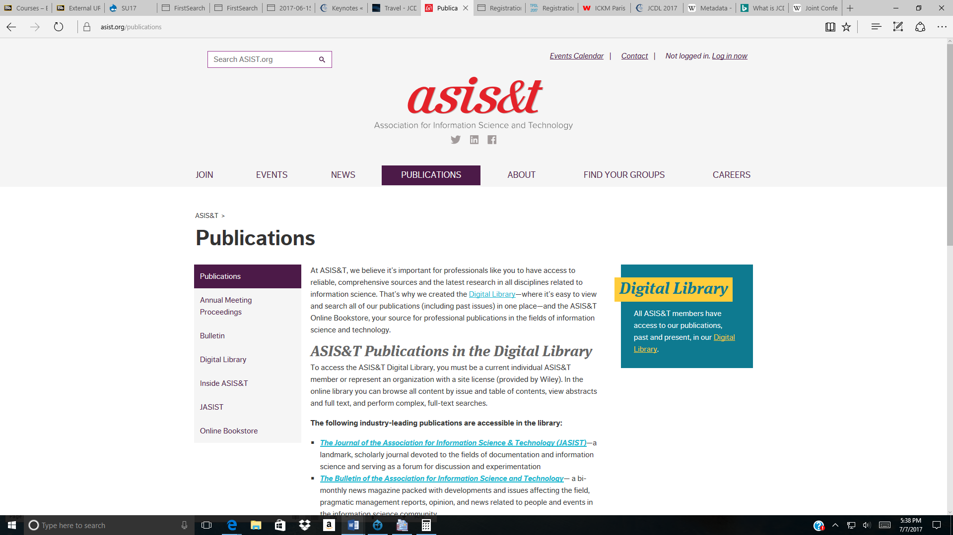

When examining the 80th Annual Meeting of the Association for Information Science and Technology website at <https://www.asist.org/events/annual-meeting/annual-meeting-2017/>

It seemed like there were not a lot of tabs just for the 2017 conference site. The global navigation tabs at the top immediately takes the user to assist.org main website. There were only five main tabs and they didn’t seem very informative. Once a user clicked a link, it would look like the user was taken to a completely different website, which seemed very confusing at times. Also, some of the other pages had very vivid colors and large graphics, which were very distracting at times.

Observations:

* Use color schemes that are not distracting from content. Use color schemes that don’t hurt the eyes when looking at a site.
* Make sure labels are concise and understandable.
* Make sure links clearly portray the information that can be found when clicking it.

#### Lessons Learned from Benchmarking:

* Navigation links need to be easily seen and make sense per content it links to.
* Labels need to accurately represent data.
* If needed, use top of page links.
* Use drop-down menus for links.
* Do not use text links for important links.
* Do not put important links in middle of or bottom of page.
* Use a consistent style of navigation links.
* Use headings and tabs to make content stand out.
* Use tables to separate information when needed.
* Ensure content is organized neatly and inviting.
* Do not use bright colors that are distracting.

## 3.1.2 Metadata and Content Analysis

### Content Analysis

One thing that stood out when analyzing the content of the 2017 JCDL website is that while it was clean and simple, it was not inviting for new or potential participants to the conference. When looking at the 2016 JCDL website, it seemed very cluttered with information but it offered more information for those wanting to know more about the conference and its purpose. This should be considered in the design of the new website.

The main focus of the JCDL website is to provide information for their annual conference to all potential attendees. That information largely consists of information about sponsors and organizers, presenters, registration, current JCDL news, accommodations, venue and conference attractions, important dates, and scheduling. However, there was no option for performing a search within the JCDL 2017 website.

A user may choose to contact the website but the only information that is given is a spot for the user to enter the Name, Email, and message. There is no actual contact information when the user clicks the contact link, nor does it ever inform the user who they are contacting when they send their message.

In presenting the information the website utilizes textual documents in the form of web pages, video files, maps, PDF’s, Power Point, and links to resources such as sponsors, committees, and contributors to the conference.

The website has incorporated a variety of document types in its design to represent the opportunities, purposes, and theme of the conference and organizers:

* Accepted papers
* Accepted posters and demos
* Submission Forms
  + Full and short papers
  + Posters and demonstrations
  + Workshops
  + Tutorials
* Online registration
* Important dates
* Organization members
* Committee members
* Venue information
* Power Point Presentation

The main source for a majority of the website content originates from the following major sponsors:

* SIGWEB (Special Interest Groups on Hypertext, Hypermedia, and Web)
* ACM (Association for Computing Machinery)
* SIGIR (Special Interest Group on Information Retrieval)
* IEEE Computer Society
* TCDL (Technical Committee on Digital Libraries)

Included also is the social media presence, with a Facebook page and Twitter feed.

Subjects identified on the JCDL Conference home page are registration, theme, program, venue location, accommodations, organizing and programming committee directory and profiles, schedule, attractions, and about.

The new website will be designed to be consistent with the existing architecture combined with lessons learned from the four websites analyzed during the content research phase.

### Metadata

Metadata for the content of the website will be evaluated from past JCDL websites and results of the card sorting tool applied to a diverse background of users. The incentive is to ensure consistency throughout the website to provide familiarity for the users allowing them to have a pleasant experience but most importantly fulfill their informational needs.

Some of the images used within the website seemed to make sense for what the image was representing, though there were other images that didn’t seem to quite fit in, for example, on the home page when the user scrolls down, the image next to Keynote Speakers is a podium with a bunch of microphones. However, the image next to Registration Now Open is an envelope with a hand poking out of it hold a megaphone. Images should represent the information it portrays.

The 2017 site did use consistent headings on pages that matched the label link name. Style of text seemed to be consistent. On the Schedule page, the scheduled events where nicely organized by using color to distinguish each scheduled entry to separate by type of event. If speakers or members have images for their profiles this should be included too.

The “about Toronto” page where Attraction information is found has many textual links that clearly explain in the text link the exact description of where the user will be taken if the link is clicked. If textual links are used they should clearly explain themselves with descriptive links. Consistent text size should be used in between pages.

# 4.1 Users

## 4.1.1 Card Sorting

Team One administered a card sort, based on elements from the JCDL 2017 site and several others from competitive sites, to sixteen people. Participants were instructed to group items in four to six categories, and determine a suitable name for each category (Table 1-Appendix A.1). Team One then tried to determine standardized names for each user category, as much as possible, applying names to multiple users’ categories (Table 2-Appendix A.2).

Quantitative analysis of the data (Table 3-Appendix A.3) indicated that, other than elements pertaining to registration and conference agenda, the labeling used was not consistently understood, and that less ambiguous labeling is required. The challenge in label design for this project is to make language clear while remaining concise. Participants in the card sort included librarians, paralibrarians and LIS students, because they seemed to be the most readily available subjects who would come closest to fitting our user profile. In retrospect, rather than focusing on LIS professionals exclusively, consultation with academics in other disciplines who regularly attend conferences may be of value in better understanding labeling needs of users.

The client has emphasized the importance of Visa information being readily findable for international conference attendees, so placing links to that information in more than one place within the architecture is desirable despite being redundant. Results of the card sort indicate that other information links might be suitably placed in more than one dropdown menu or another area in the navigation structure.

# 5.1 Blueprints

The website blueprint illustrates the actual structure and design of a website including its labeling system. The blueprints further purpose is to visually show the organization and relationships between the components that make up the website. The following blueprint is a high-level blueprint that shows the relationship of the sites main components and pages in a top-down information architecture approach.

## 5.1.1 Blueprint – Home Page High-level diagram

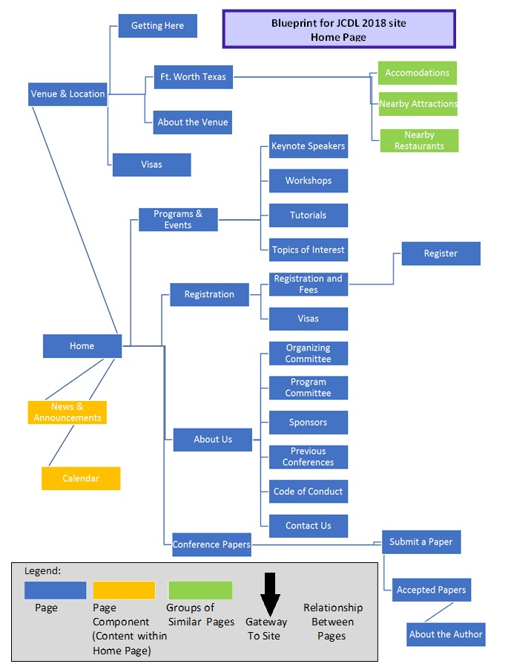

# 5.2 Wireframes

When designing websites one step in the information architecture process is designing wireframes. Wireframes are a visual representation of an individual page design layout. Creating wireframes allows the designer(s) to ensure they completely understand the projects design as well as visually see the placement of elements within each page.

## 5.2.1 Low Fidelity Wireframe (See Figure 1)

The low fidelity wireframe visually demonstrates the layout of a websites individual page by showing the location placement of the following: logo and header, global navigation, page title, page content, social media links, and footer. The following low fidelity wireframe is the basic layout of the JCDL 2018 home page.

## 5.2.2 Medium Fidelity Wireframe (See Figure 2)

The medium fidelity wireframe adds to the low fidelity wireframe by showing the global navigation labels, “Home, Programs & Events, Registration, Conference Papers, Venue & Location, About Us.” It also labels the content that will be in different areas by labeling with a number and description that the number represents is below the wireframe such as, slogan, search box location, etc.

## 5.2.3 High Fidelity Wireframe (See Figure 3)

The high fidelity wireframe is almost a complete visual design of what the actual completed page will look like. This allows the designer(s) to ensure that all elements fit, look organized, and all information is easily accessible and understandable. The following high fidelity wireframe furthers the completion of the medium wireframe by inputting the Logo & Header, the image, visually showing the page content section and calendar area. It also shows the second navigation system located at the bottom on the page in the footer as well as the search box.

### Figure 1 – Low Fidelity Wireframe – Home Page

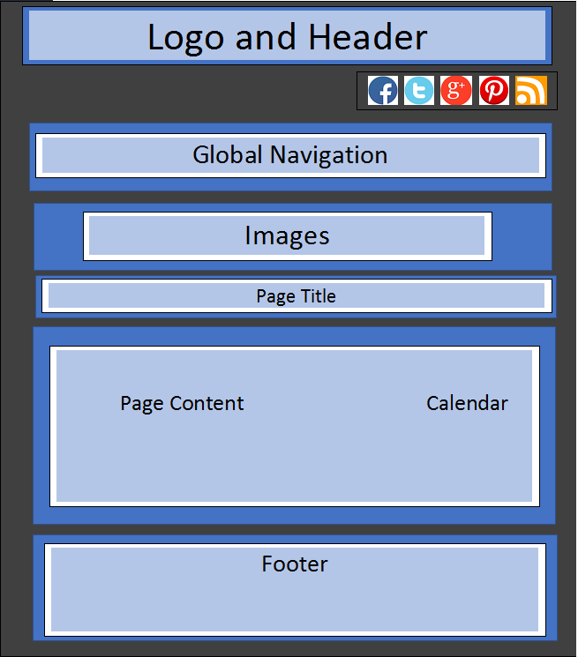

### Figure 2 – Medium Fidelity Wireframe – Home Page

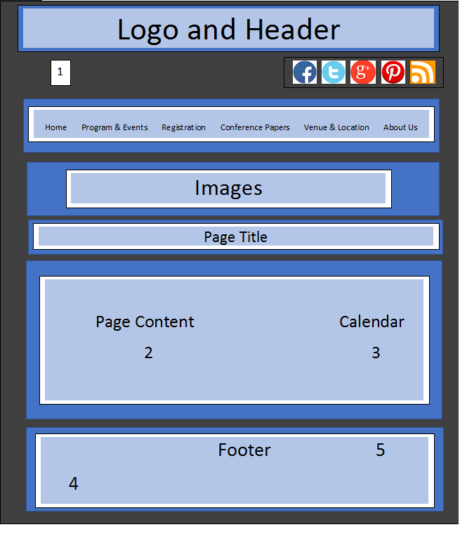

1 – Slogan – From Data to Wisdom: Resilient Integration across Societies, Disciplines, & Systems

2 – News and Announcements

3 – Calendar with dates of events entered on it

4.- Secondary Navigation Area

5. – Search Box

### Figure 3 High Fidelity Wireframe – Home Page

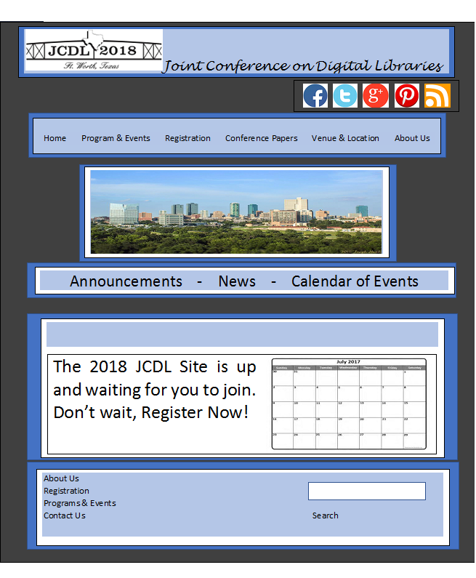

# 5.3 Content Mapping and Inventory

Content mapping is a web designing tool to provide visual representation on the existing information environment (Rosenfeld, Arango, & Morville, 2015). It is a conceptual tool that provides website designers with an understanding on the site content construction in its relationship to the goals of the organization and users. This strategy helps to ensure that the emphasis on the content is relevant, identifies content areas lacking information, facilitates navigation, and to foster collaboration amongst the designing team.

Content inventory works in conjunction with content mapping by describing the various contents of the site and where they can be located. This analysis reinforces the strategies and goals propagated by content mapping.

## 5.3.1 JCDL 2018 Content Mapping and Inventory

|  |  |  |  |  |
| --- | --- | --- | --- | --- |
| ID # | Page Name | Description | Location | Content |
| 1.0 | Home | Main | Home Page | Page title Links to “Venue & Location, Programs & Events, Registration, About Us, Conference Papers” News & Announcements |
| 1.1 | News & Announcements | Banner/Content Component | Home page | Current reading, event calendar |
| 2.0 | About Us | Sub-Page | Sub-page, linked from Home page | Page Title Links to “Organizing Committee, Program Committee, Sponsors, Previous Conferences, Code of Conduct, Contact Us” |
| 2.1 | Organizing Committee | Details about Organizing Committee Members | Linked from About Us page | Page title List of Organizing Committee Members |
| 2.2 | Program Committee | Details about Program Committee Members | Linked from About Us page | Page title List of Program Committee Members |
| 2.3 | Sponsors | Details about Sponsors for JCDL | Linked from About Us page | Page title List of Sponsors |
| 2.4 | Previous Conferences | Details about previous conferences | Linked from About Us page | Page title  List of links to previous JCDL conferences |
| 2.5 | Code of Conduct | Details of Code of Conduct | Linked from About Us page | Page title  Code of Conduct information |
| 2.6 | Contact Us | Details of contacting site/leaving message | Linked from About Us page | Page title  Contact Us information and/or leave a message |
| 3.0 | Conference Papers | Sub-Page | Sub-page, linked from Home page | Page Title links to “Submit a Paper, Accepted Papers” |
| 3.1 | Submit a Paper | Details on how to submit a paper | Linked from Conference Papers | Page title  Information on submitting a paper |
| 3.2 | Accepted Papers | Approved accepted papers | Linked from Conference Papers | Page title  List of approved accepted papers |
| 3.2.1 | About the Author | Information about Authors of accepted papers | Linked from About the Author | Page Title  Information about accepted paper authors |
| 4.0 | Registration | Sub-Page | Sub-page, linked from home page | Page Title links to “Registration & Fees, Register” |
| 4.1 | Registration & Fees | Registration process | Linked from Registration page | Page Title  Information to registering on-line, conference dates, workshops, & fees |
| 4.1.1 | Register | On-line registration | Linked from Registration & Fees page | Page Title  Registration Process |
| 4.2 | Visas | On-line Visa application | Linked from Registration page | Page Title  Information on applying for visitor visas |
| 5.0 | Programs & Events | Sub-Page | Sub-page, linked from Home page | Page Title links to “Keynote Speakers, Workshops, Tutorials, Topics of Interest” |
| 5.1 | Keynote Speakers | Details about Keynote Speakers | Linked from Program & Events | Page Title  Listing of Keynote Speakers and topics |
| 5.2 | Workshops | Information & listing of full-day & half-day workshops to be presented | Linked from Program & Events | Page Title  List and details of workshops |
| 5.3 | Tutorials | Information & listing of times & dates for tutorials to be presented | Linked from Program & Events | Page Title  Details of tutorials |
| 5.4 | Topics of Interest | Information on the topics of interest that focus on this year’s theme | Linked from Program & Events | Page Title  Lists Topics of Interest |
| 6.0 | Venue & Location | Sub-Page | Sub-page, linked from Home page | Page Title links to “Getting Here, About the Venue, Ft. Worth Texas, Visas” |
| 6.1 | Getting Here | List of different avenues of travel to arrive at the Conference | Linked from Venue & Location | Page Title  List of traveling directions to venue |
| 6.2 | About the Venue | Information of the location of the venue and its surrounding area | Linked from Venue & Location | Page Title  Details about the conference venue |
| 6.3 | Ft. Worth Texas | Information on facts, places of interest, and events in Ft. Worth Texas | Linked from Venue & Location | Page Title  Details of Ft. Worth Texas |
| 6.3.1 | Accommodations | Information on different hotels and prices | Sub-page linked from Ft. Worth Texas | Page Title  links to different accommodation sub sites |
| 6.3.2 | Nearby Attractions | Information of various local events and sightseeing attractions | Sub-page linked from Ft. Worth Texas | Page Title  links to different attraction sub sites |
| 6.3.3 | Nearby Restaurants | Information on restaurants within close proximity | Sub-page linked from Ft. Worth Texas | Page Title  links to different restaurant sub sites |
| 6.4 | Visas | Information on On-line Visa application | Sub-page linked from Ft. Worth Texas | Page Title  Information on applying for visitor visas |
| 7.0 | Calendar & Events | Sub-Page | Sub-page, linked from home page | Page Title  links back to homepage (adding extra global link so users know how to get back to calendar and event news |

# 5.4 Controlled Vocabulary

The controlled vocabulary and thesaurus have been developed to support consistent labelling throughout the site while maximizing findability. The terms have been chosen based on several factors, including (a) content analysis, (b) terms chosen by participants in the card sort, (c) word associations suggested by the results of the card sort, and (d) review of websites for other conferences related to information science topics. The controlled vocabulary can continue to be adjusted and expanded with information gathered from feedback from stakeholders and analysis of search logs.

Legend:

USE     = Use the preferred term  
UF        = Use For  
NT       = Narrow Term  
BT       = Broad Term  
RT       = Related Term  
**Preferred terms are bold**

**About the Venue**

UF Location

BT **Venue & Location**

NT **Getting Here**

**About us**

UF Conference planning

UF Committee

UF Organization

NT **Organizing Committee**

NT **Program Committee**

NT **Sponsors**

Accepted Authors

USE **Accepted Papers**

**Accepted Papers**

UF Accepted Authors

UF Submissions

**Accommodations**

UF Hotels

UF Lodging

UF Places to stay

UF Where to stay

UF Arrangements

RT **Fort Worth**

Activities

USE **Nearby Attractions**

Agenda

USE **Calendar**

Arrangements

USE **Accommodations**

Attend

USE **Register**

Attractions

USE **Nearby Attractions**

**Calendar**

UF Agenda

UF Important Dates

UF Schedule

UF Itinerary

Committee

USE **About Us**

Conference Articles

USE **Conference Papers**

Conference Essays

USE **Conference Papers**

Conference news

USE **News & Announcements**

**Conference Papers**

UF Conference Essays

UF Conference Articles

RT **Accepted Papers**

RT **Submit a Paper**

Conference planning

USE **About us**

Conference Speakers

USE **Keynote Speakers**

Conference updates

USE **News & Announcements**

**Contact us**

UF Questions

UF Suggestions

RT **About Us**

Cuisine

USE **Nearby Restaurants**

Directions

USE **Getting Here**

Driving Directions

USE **Getting Here**

Events

USE **Programs & Events**

Enroll

USE **Registration**

Entertainment

USE **Nearby Attractions**

Food & Beverage

USE **Nearby Restaurants**

**Fort Worth**

UF Ft. Worth

RT **Accommodations**

RT **Nearby Attractions**

RT **Nearby Restaurants**

RT **Venue & Location**

Ft. Worth

USE **Fort Worth**

**Getting Here**

UF Travel

UF Directions

UF Driving Instructions

Hotels

USE **Accommodations**

Hotels

USE **Accommodations**

Important Dates

USE **Calendar**

Interest

USE **Topics of Interest**

Itinerary

USE **Calendar**

**Keynote Speakers**

UF Conference Speakers

UF Presenters

BT **Programs & Events**

Location

USE **About the Venue**

Lodging

USE **Accommodations**

**Nearby Attractions**

UF Activities

UF Attractions

UF Entertainment

UF Things to Do

RT **Fort Worth**

**Nearby Restaurants**

UF Food & Beverage

UF Restaurants

UF Cuisine

RT **Fort Worth**

**News & Announcements**

UF Stay Connected

UF Conference News

UF Conference updates

Organization

USE **About Us**

Organizing Board

USE **Organizing Committee**

Organizing Commission

USE **Organizing Committee**

**Organizing Committee**

UF Organizing Board

UF Organizing Commission

UF Organizing Members

BT **About Us**

Organizing Members

USE **Organizing Committee**

Paper Submission

USE **Submit a Paper**

Past Conferences

USE **Previous Conferences**

Places to stay

USE **Accommodations**

Presenters

USE **Keynote Speakers**

**Previous Conferences**

UF Past conferences

UF Prior conferences

BT **About us**

Prior Conferences

USE **Previous Conferences**

Pricing

USE **Registration & Fees**

**Program & Events**

UF Events

UF Programs

UF Programming

UF Substance

NT **Topics of Interest**

NT **Keynote speakers**

NT **Workshops**

NT **Tutorials**

Program Board

USE **Program Committee**

Program Commission

USE **Program Committee**

**Program Committee**

UF Program Commission

UF Program Members

UF Program Board

Program Members

USE **Program Committee**

Programming

USE **Programs & Events**

Programs

USE **Programs & Events**

**Programs & Events**

UF Programming

UF Programs

Questions

USE **Contact Us**

Restaurants

USE **Nearby Restaurants**

**Register**

RT **Visas**

RT **Registration**

**Registration**

UF Enroll

NT **Registration & Fees**

RT **Register**

RT **Visas**

**Registration & Fees**

BT **Registration**

Schedule

USE **Calendar**

Site

USE **Venue & Location**

**Sponsors**

BT **About us**

Stay connected

USE **News & Announcements**

Subjects

USE **Topics of Interest**

Submissions

USE **Accepted Papers**

**Submit a paper**

UF Paper Submission

RT **Accepted Papers**

RT **Conference Papers**

Substance

USE **Programs & Events**

Suggestions

USE **Contact us**

Things to Do

USE **Nearby Attractions**

**Topics of Interest**

UF Subjects

UF Interests

NT **Programs & Events**

Travel

USE **Getting here**

**Tutorials**

BT **Programs & Events**

**Venue & Location**

UF Site

NT **About the venue**

RT **Fort Worth**

**Visas**

RT **Registration**

RT **Register**

Where to stay

USE **Accommodations**

**Workshops**

BT **Programs & Events**

# 5.5 Summary of Team Interaction

The following table lists each team member and their assigned task. However, each team member played a role in each part by making edits and/or suggestions to their following team mates assigned task.

|  |  |  |
| --- | --- | --- |
|  | | |
| 2.1 | Rabecca Pate | Blueprints |
| 2.2 | Rabecca Pate | Wireframes |
| 2.3 | Loring Faiivae | Content Mapping & Inventory |
| 2.4 | Edmund Lowe | Controlled Vocabulary |

# 6.1 Prototype for New Site

The prototype for the new 2018 JCDL site is located at:

coolt-courses.lis.unt.edu/SU17t1

Since the design of the blueprint and Home page wireframe some changes have been made which should be noted.

* Search box was moved to the top right of the screen instead of in the footer.
* Some link names have slightly changed such as Registration to Registration Info.
* User Login and user menu has been moved to its own main menu link since only authorized users only need this access.

Some pages are incomplete, mainly due to information and/or data not being available at this time. As this information and/or data becomes available, it will be inputted into the site. Feedback from the stakeholders as well as further usability testing will inform additional changes.

# 6.2 Design Implementation

The information architecture implementation for the 2018 JCDL website was created using Drupal, which is, an open source content management software that is written in PHP and distributed under the General Public License and is built on principles of collaboration, globalism, and innovation (drupal.org). For the 2018 JCDL website the Creative theme 7.x-1.0 was used along with different modules which were downloaded for the purpose of increasing the functionality of the prototype.

While most pages were created with the basic page function, there were some pages that were created using a different method. For example, the ‘Submit a Paper’ page was created using the Webform module. The calendar event dates were created by using the Event Calendar Module. Most formatting on pages was formatted by entering the HTML code or CSS code directly into the page, this was done in order to have more control over certain formatting. Controlled vocabulary was added in order for users to still be able to locate information that resembles their search query, however, clear and understandable directions could never be located in order to fully implement this function. Further research must be done in order to implement this function.

For individuals who have a profile website/page absolute reference linking was used. This will be the same technique used when authors of accepted papers are known and entered into the website, and this will allow individuals to easily request more information about the author. Everything that an individual needs to know about the conference at this time has been incorporated, including dates of submission deadlines, a form for submitting submissions, as well as information about the venue and nearby accommodations.

Lastly, stakeholders emphasized the importance of making Visa information easy to locate. The Visa link has purposely been added to two different locations which are under the ‘Registration Info’ tab and the ‘Venue & Location’ tab. Depending on which country a traveler is traveling from determines which Visa form they will fill out, which is why, a link has been provided on the Visa page, that will take users directly to the United States Visa form information page. As mentioned above the functioning prototype can be accessed at:

coolt-courses.lis.unt.edu/SU17t1

# 6.3 Personal Reflections

After completing the information architecture design process and implementing the design into a functional prototype, each team member reflected on their individual experience by summarizing their overall project experience.

## 6.3.1 Statement from Loring Faiivae

Having no prior experience in working with content management software or creating a website I was very thankful and fortunate to be on Team One. The collaboration with peers was instrumental in allowing for a good learning experience. There was a lot of constructive criticism and positive conversation in the design of the website. This was a great learning opportunity to gain a better understanding on the amount of work and planning that goes into the process of creating websites.

Drupal is a powerful content management software loaded with features and tools but I would not suggest it for a novice especially if they are working alone. Drupal is intimidating and requires prior knowledge on the variety of enhancements it provides. Drupal is also loaded with information on the administration and implementation but at times I got lost and frustrated in trying to sift through it all. I feel that Drupal is better suited for seasoned website designers that know what they want their website to look like.

## 6.3.2 Statement from Edmund (Steven) Lowe

I found administering and analyzing the card sorting exercise to be very enlightening. I found some of the results surprising, and it gave me a different perspective on organization of the content and demonstrated that there are a variety of ways users can understand information systems. More than that, it is a simple but brilliant tool that can eliminate a lot of guesswork and save information architects a great deal of time and mental energy by providing insight into users' thought processes.

The controlled vocabulary raised several issues. Determining semantic relationships among the vocabulary was an interesting challenge, not unlike putting together a puzzle. However, it was difficult to figure out how to use the Drupal taxonomy module to maximum effectiveness, and the documentation left a number of questions unanswered. My understanding of the purpose of the taxonomy was that it should serve a similar function to that of an authority database in a library catalog, enabling users to find content even if they use alternative language. Rabecca and I tried to make the controlled vocabulary functional in this way, but we were unable to link it to the actual content of the site. Several times, one of us thought we might be onto something, but it would turn out to be a dead end. While I think the controlled vocabulary is a useful reference for others who work on the site, I was disappointed that we were unable to integrate it into the inner workings of the site.

The team coordinator did an excellent job of keeping everyone on task and keeping the project moving on schedule. The other two team members demonstrated great creativity, flexibility and skill in approaching the work. They were also very responsive to communication and very supportive of me and of each other. It was a pleasure collaborating with this team.

## 6.3.3 Statement from Rabecca Pate

This project gave realistic experience to the Information Architecture design process. When first seeing what the whole project entailed at the beginning of the semester I was very nervous and thought I was in over my head. But doing different assignments gave me direction in how to do parts of the project that I previously felt concerned about. Implementing the actual website using Drupal was very frustrating at times. I wished the assignment where we critiqued the Drupal.org was at the end of the semester. I would have had a lot more to say about its website and about where I actually located information on how to use different modules that I ended up using for our website design.

In the end, I can see how Drupal is a very powerful tool in creating great websites. Nevertheless, there are not really any good instructions to be found when needing help in using a Drupal module. However, after spending many hours, I was able to implement many functions that the JCDL 2018 site required. When it comes to my team members I could not have asked for a better team, any time I asked for something they immediately acknowledge me and got back to me with an answer or solution. Communication was more than superb and my team members were very knowledgeable and helped me anytime I asked. I can only hope that in future classes I have a team as great as I did on this project. I am really glad I took this class and feel I have learned a lot that will benefit me throughout not only my education but my career as well.

# 

# References

40th International ACM SIGIR Conference on Research and Development in Information Retrieval. (n.d.). Retrieved July 09, 2017, from http://sigir.org/sigir2017/

About Drupal. (n.d.). Retrieved August 08, 2017, from https://www.drupal.org/about

About JCDL. (n.d.). Retrieved July 09, 2017, from http://jcdl.org/about.php

Annual Meeting 2017: 80th Annual Meeting of the Association for Information Science and Technology. (n.d.). Retrieved July 09, 2017, from https://www.asist.org/events/annual-meeting/annual-meeting-2017/

ICKM 2017: 19th International Conference on Knowledge Management, Paris, France, June 25-26, 2017. (n.d.). Retrieved July 09, 2017, from https://www.waset.org/conference/2017/06/paris/ICKM/call-for-papers

Rosenfeld, L., Morville, P., Arango, J., & Morville, P. (2015). Information architecture for the World Wide Web. Beijing: O'Reilly.

TPDL 2017: 21st International Conference on Theory and Practice of Digital Libraries. (n.d.). Retrieved July 09, 2017, from http://www.tpdl.eu/tpdl2017/

# Appendix A – Card Sort

## A.1 - Card Sort Summary

Table 1. Card sort. Summary of user-determined category labels.

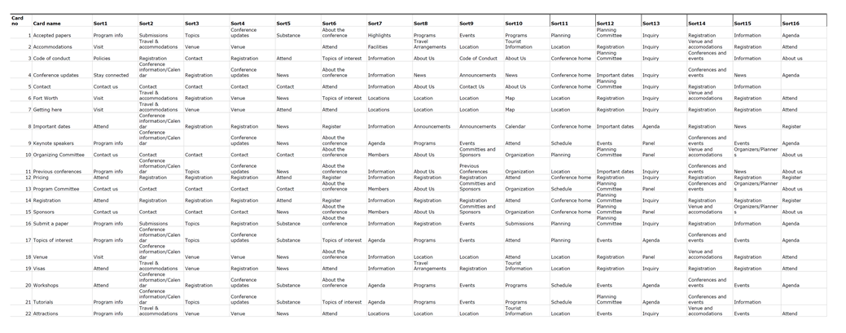

## A.2 - Card Sort Summary Standardized

Table 2. Card sort. Summary of standardized category labels

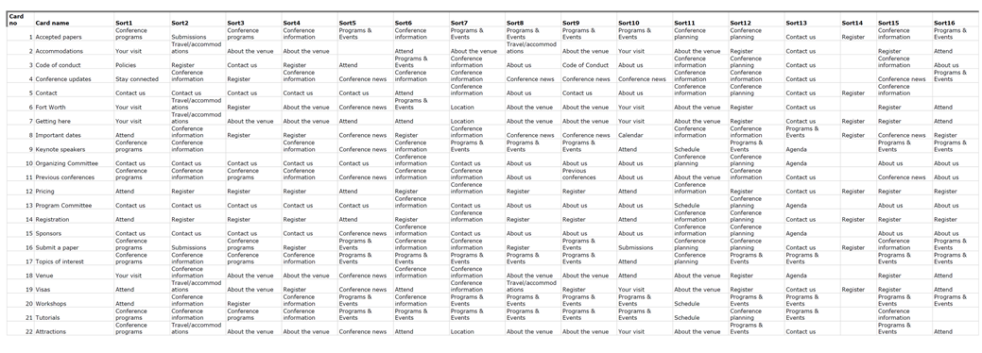

## A.3 – Card Sort Correlation

Table 3. Card sort. Correlation of standardized category labels

